**AWS Task-4**

**Task Description:**

Launch an EC2 instance (Linux and Windows) along with a web server. Then, create an EBS volume of 5 GB, attach it to an EC2 machine (Linux and Windows), and take a snapshot. Finally, create an EBS volume using the taken snapshot.

1. **Linux Instance**

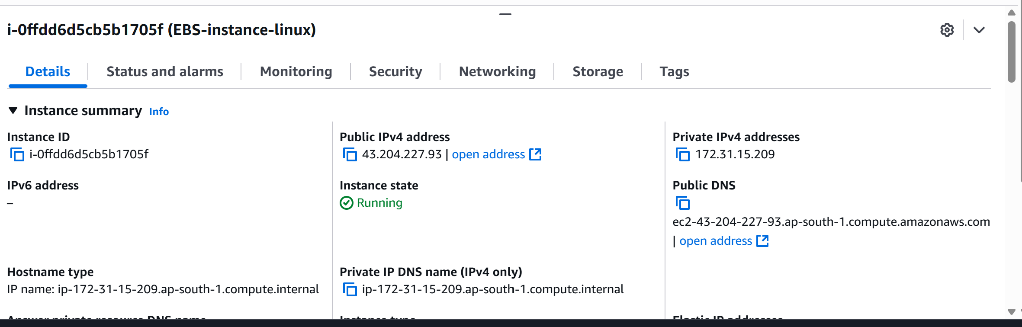

1. Allow HTTP in Security group

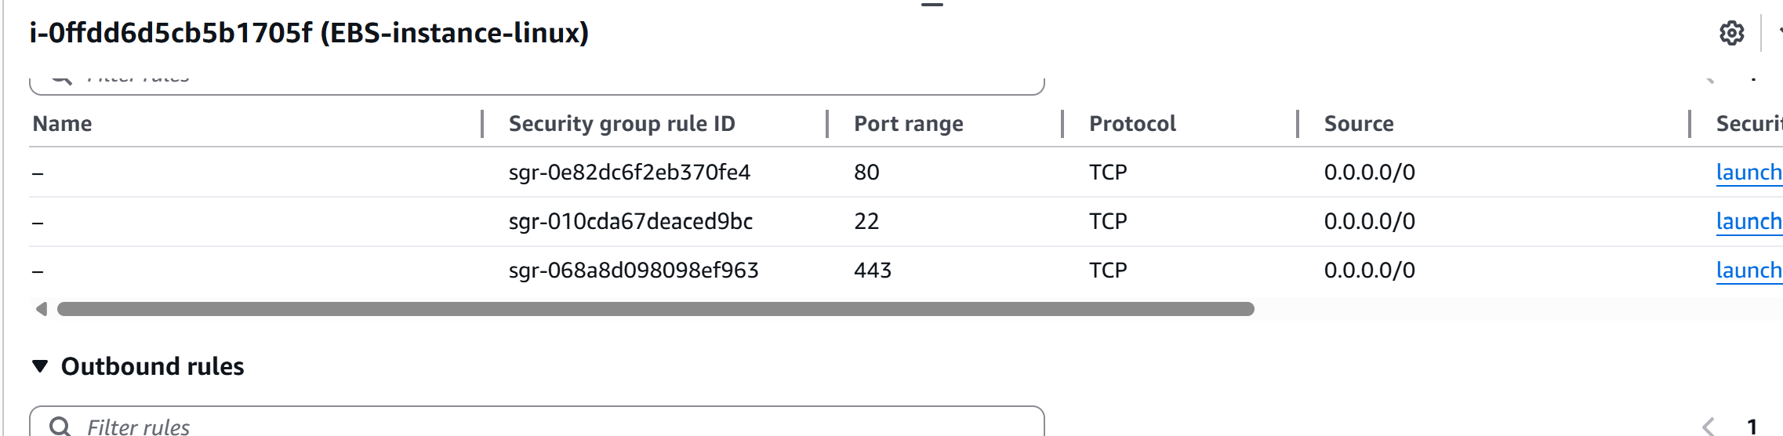

1. Installed APACHE

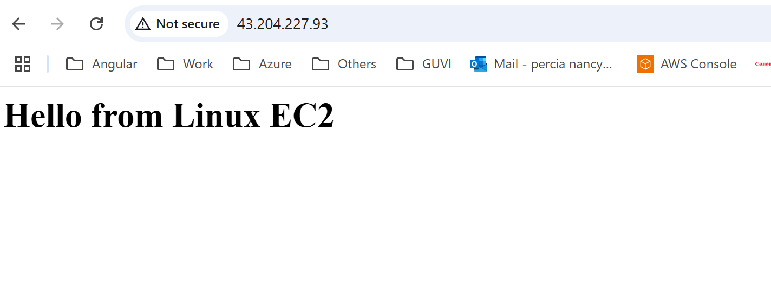

1. Windows Instance

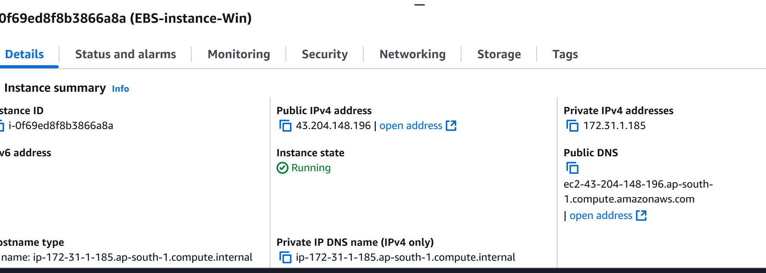

1. Allow RDP and HTTP in Security group

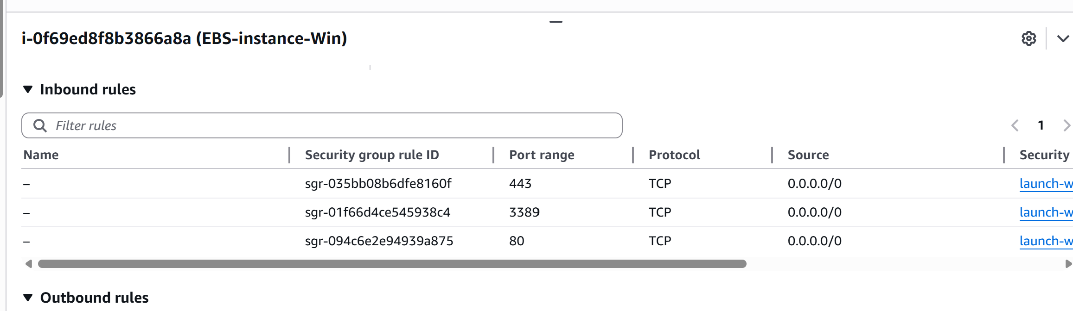

1. Connect Windows using RDP client
2. Install IIS webserver in PowerShell command or via server manager

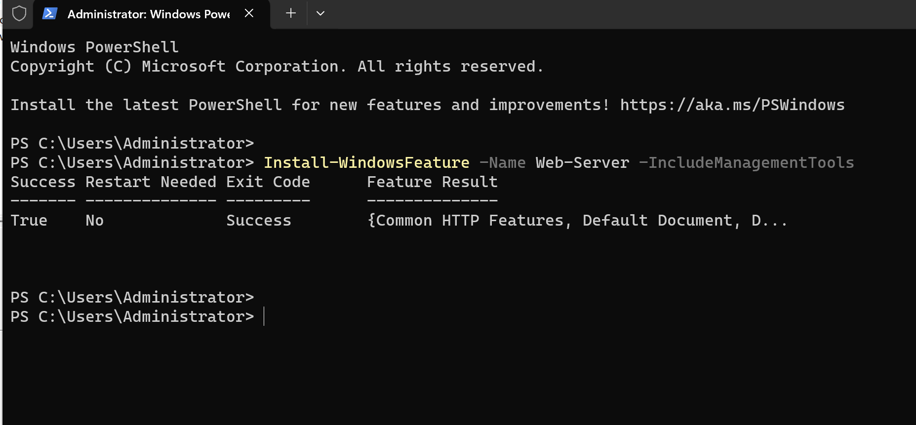

1. Modified the default file from below path  
     
   C:\inetpub\wwwroot\iisstart.htm

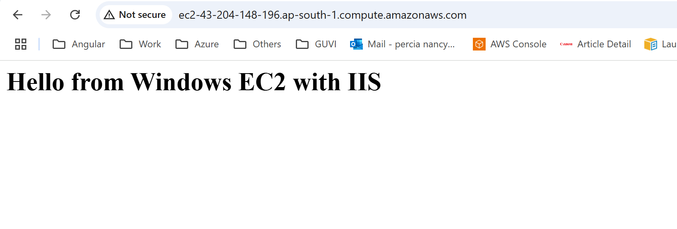

1. Create and Attach 5 GB EBS Volume .Created for Linux and Windows



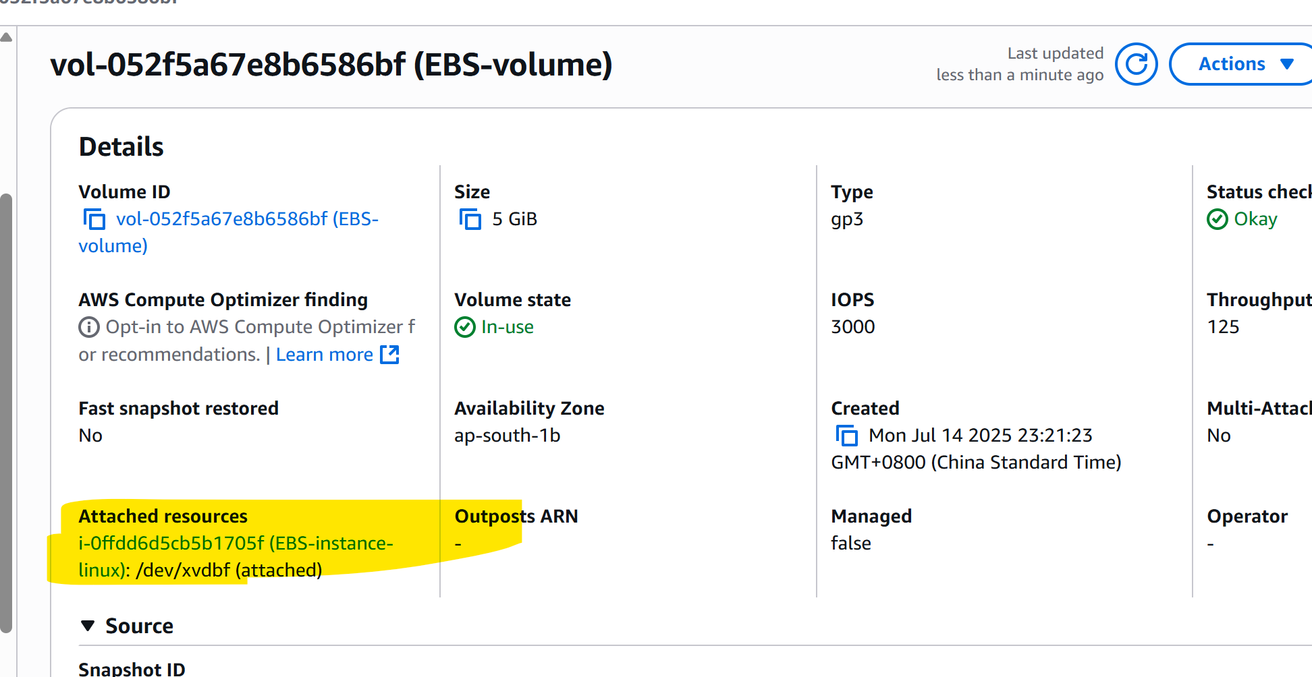

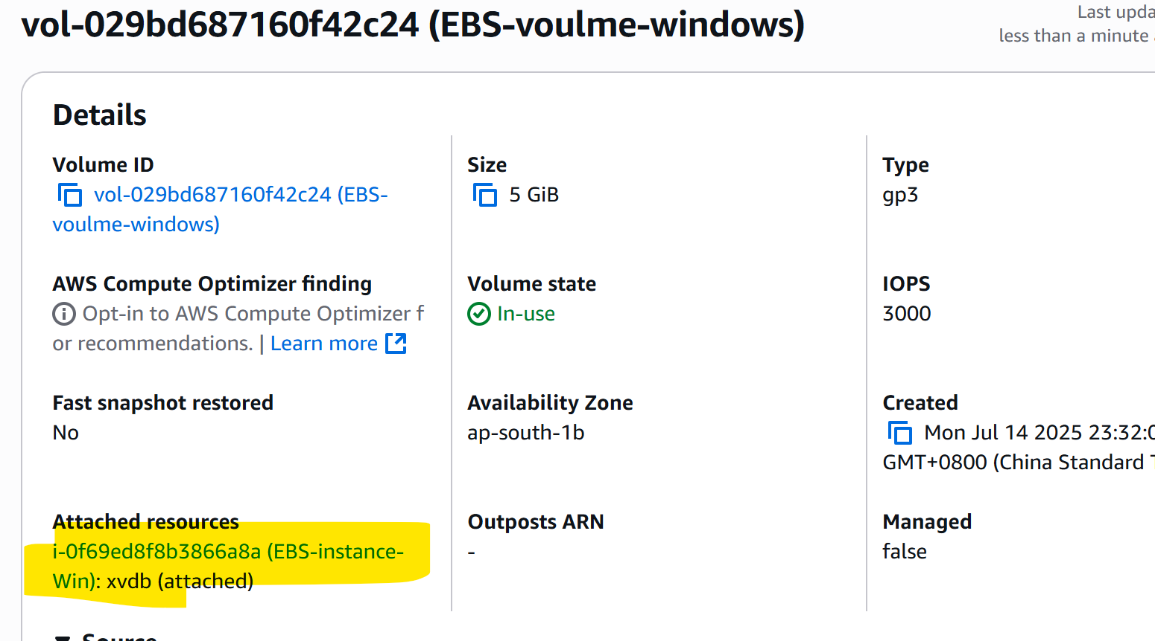

1. Format and Mount Volume in Linux

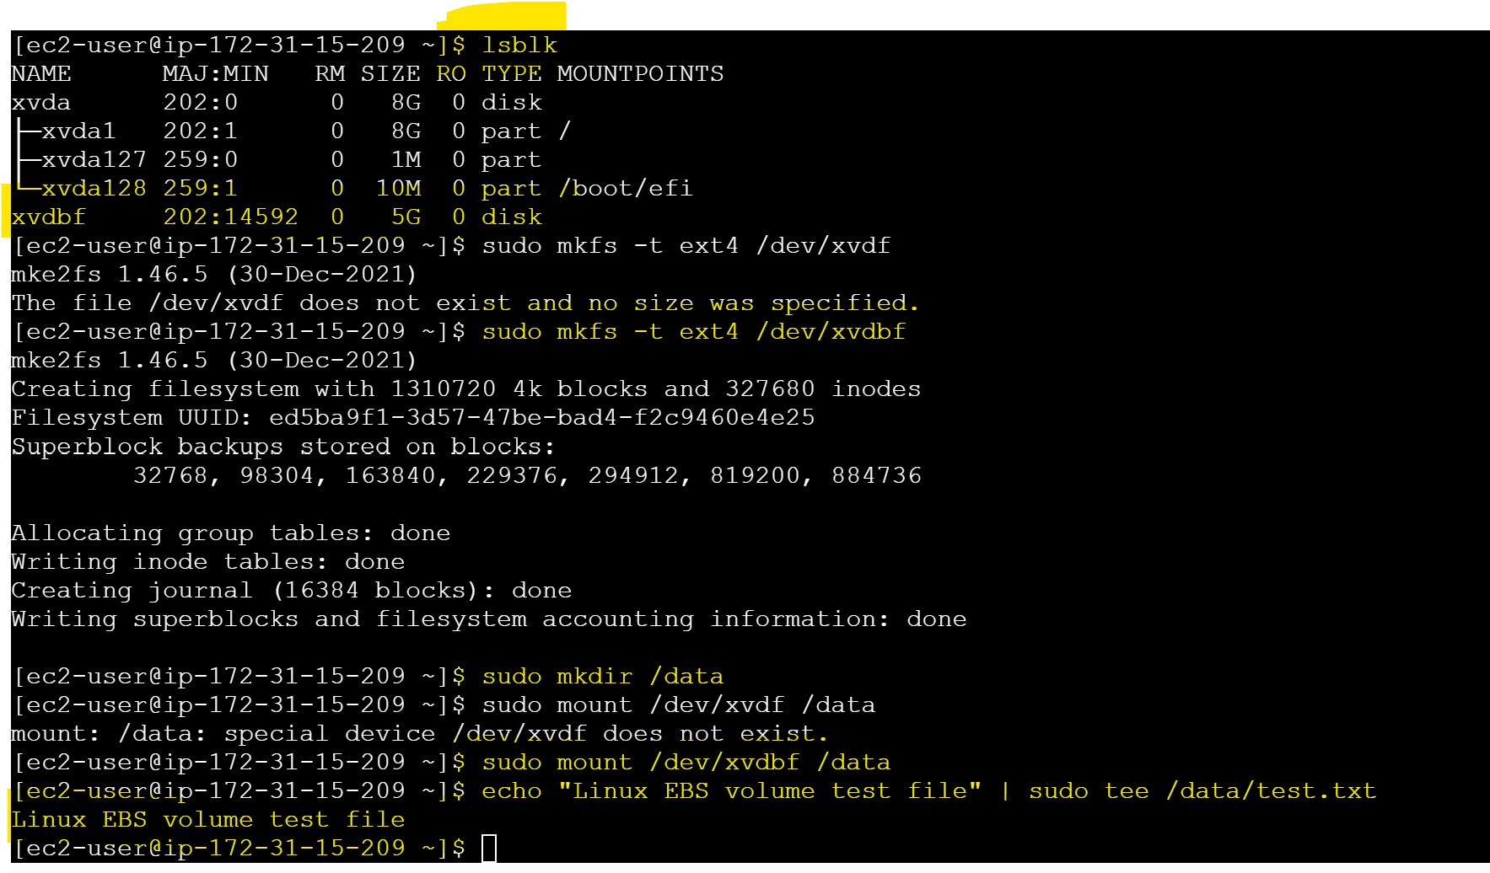

1. Format and Mount Volume in Windows

* Open **Disk Management**
* Initialize disk → Create volume → Format as **NTFS**
* Assign drive letter (E)
* Create Test.txt with sample content

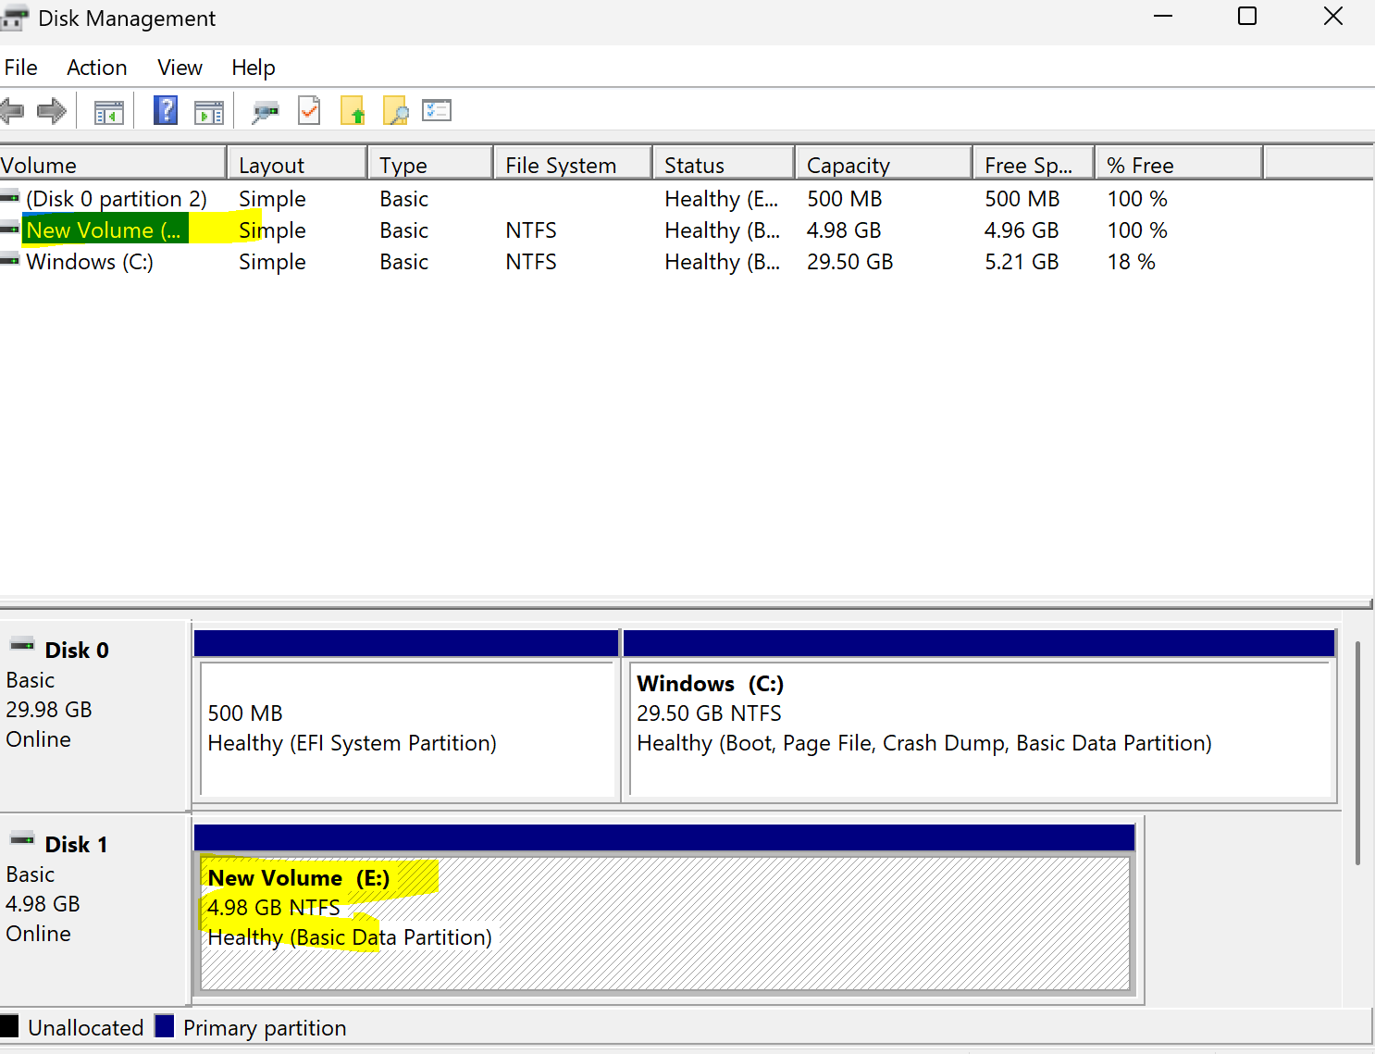

1. Add the text file inside drive E  
     
   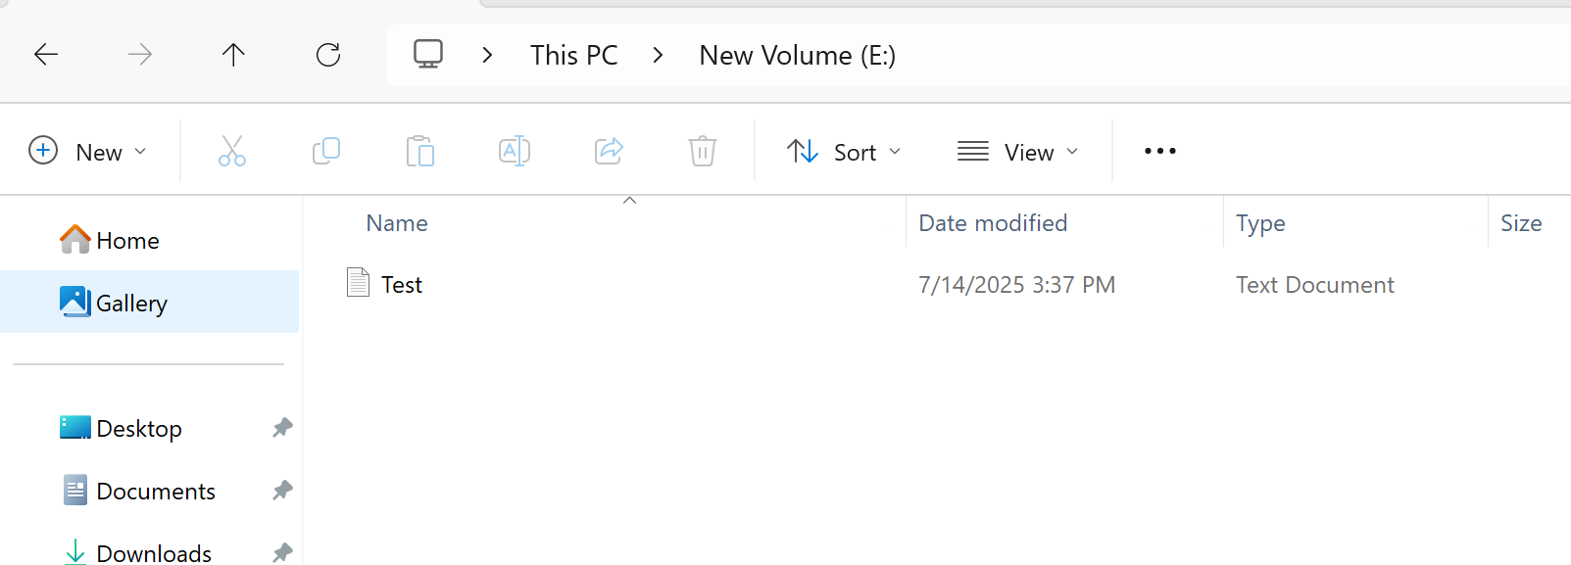
2. Take Snapshot

Go to **EC2 → Volumes → Select Volume → Actions → Create Snapshot**

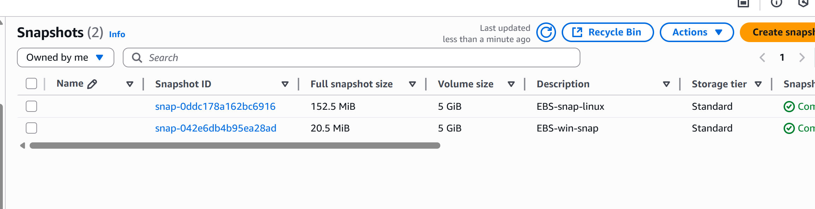

1. Create New Volume from Snapshot

Go to **Snapshots → Select → Create Volume**



1. Attaching the snapshot volume to Windows. Attach to Windows EC2
2. If disk is **offline**, bring it online in Disk Management
3. New Volume D created

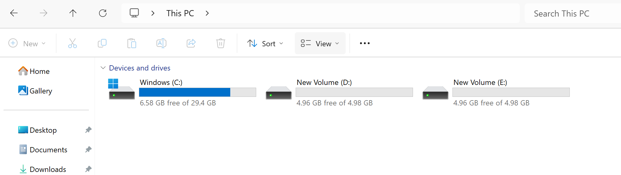

1. Test.txt is shown in D drive as well

